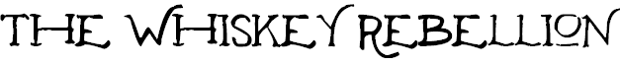

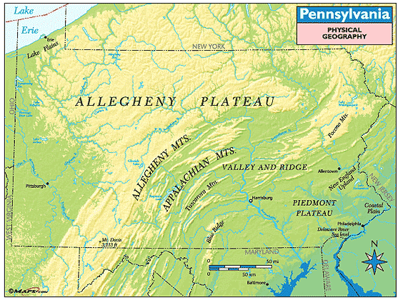

"(It was) The single largest armed confrontation (rebellion) among American citizens between the Revolution and the Civil War."
Thomas P. Slaughter-
Author and Professor of History

One of the main causes of the American Revolution also created problems after the Revolution.

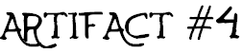
That's the only way the crops raised in the clearings can be made portable. Grain can't be packed across mountains, nor floated down to New Orleans-- the cost of such transportation is prohibitive. That's all the fuss about whiskey's all about-- farmers can barrel four times as many gallons of whiskey as the number of bushels of grain they mash. And whiskey can be sold all down the rivers, or even sent to Philadelphia-- with profit!
Abraham Overholt-
Famous whiskey distiller

"... it is in my judgment necessary under the circumstances of the case to take measures for calling forth the militia..., and to cause the laws to be duly executed; and I have accordingly determined so to do so...

I, George Washington, President of the United States, do hereby command all persons, being insurgents... to disperse and retire peaceably to their respective abodes(homes). And I do moreover warn all persons whomsoever against aiding, abetting, or comforting the perpetrators of the aforesaid treasonable acts; and do require all officers and other citizens, according to their respective duties and the laws of the land, to exert their utmost endeavors to prevent and suppress such dangerous proceedings."

George Washington-
President of the United States

