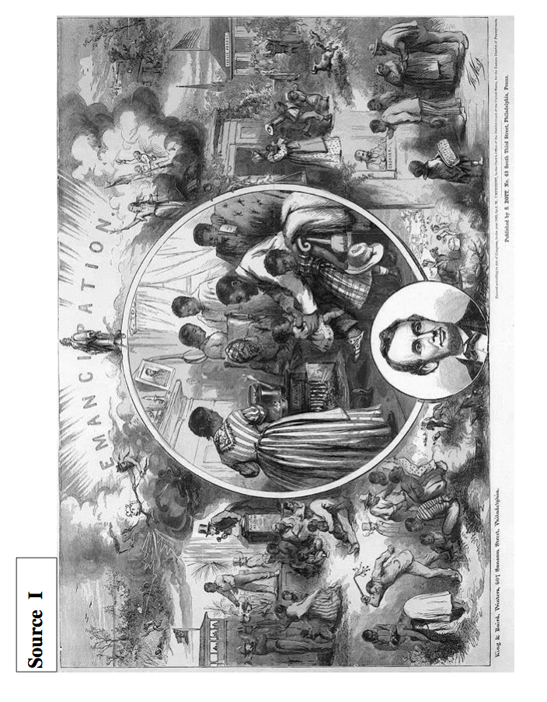
Source A
“Surprisingly fine as Mr. Everett’s oration was in the Gettysburg consecration, the rhetorical honors of the occasion were won by President Lincoln. His little speech is a perfect gem; deep in feeling, compact in thought and expression, and tasteful and elegant in every word and comma. Then it has the merit of unexpectedness in its verbal perfection and beauty... Turn back and read it over, it will repay study as a model speech. Strong feelings and a large brain are its parents.”
The Springfield Republican
November 20, 1863

Source H
“Readers will not have failed to observe the exceeding bad taste which characterized the remarks of the President . . . at the dedication of the soldier’s cemetery at Gettysburg. The cheek of every American must tingle with shame as he reads the silly, flat, and dish-watery utterances of the man who has to be pointed out to intelligent foreigners as the President of the United States.”
Chicago Times
November 20, 1863
Source D
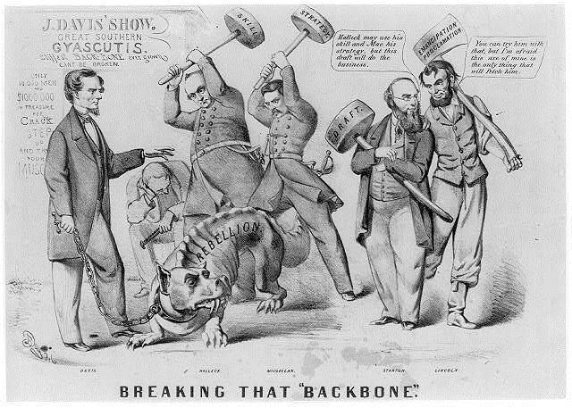

Source G
President Lincoln is a savage" and a fiend! The very ignorance which drives him to his own destruction stimulates him to the darkest excesses. What comes next will be like the Nat Turner massacre in 1831. It is one of the means which the most callous highwayman should shudder to employ. "The hellish new programme will, necessarily, destroy all terms between us. The next campaign will be a tremendous one, both for the character and magnitude of the hostility. Let our authorities prepare the whole strength of our people for a tremendous shock.
The Richmond Enquirer January 4, 1863
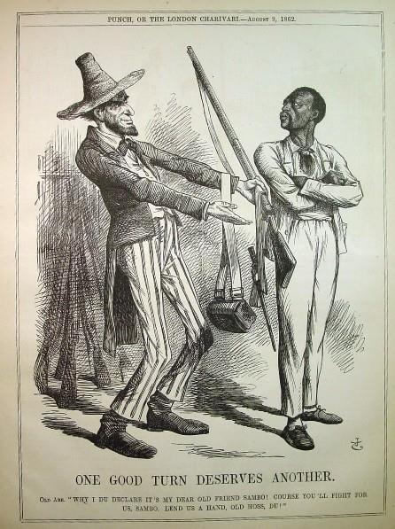
Source F

Source E
The President succeeded on this occasion because he acted without sense and without constraint in a panorama that was gotten up more for the benefit of his party than for the glory of the nation and honor of the dead ... we pass over the silly remarks of the President: for the credit of the nation we are willing that the veil of oblivion shall be dropped over them and that they shall no more be repeated or thought of.”
Harrisburg Patriot and Union: November 1863

Source C
In the rebel Senate, Mr. Semmes, of Louisiana, submitted a joint resolution on the proclamation, and said, it was "a gross outrage on the rights of private property and an invitation to servile war, and therefore should be counteracted by such severe retaliatory measures as, in the judgment of the President, may be best calculated to secure its withdrawal or arrest its execution."
Harper’s Weekly January 6, 1863

Source B
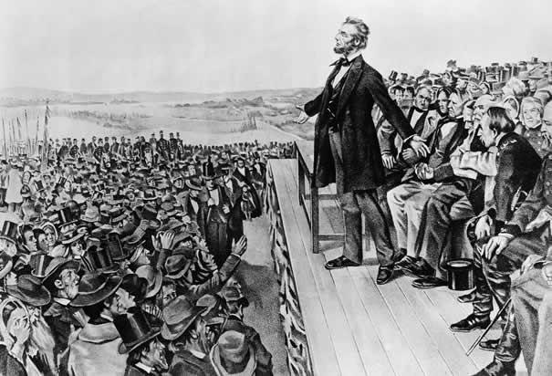
“Lincoln’s Great Speech” Wherwood Lithograph of Lincoln at Gettysburg

