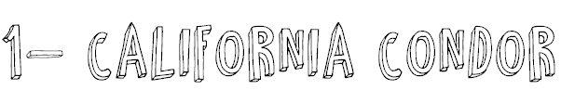

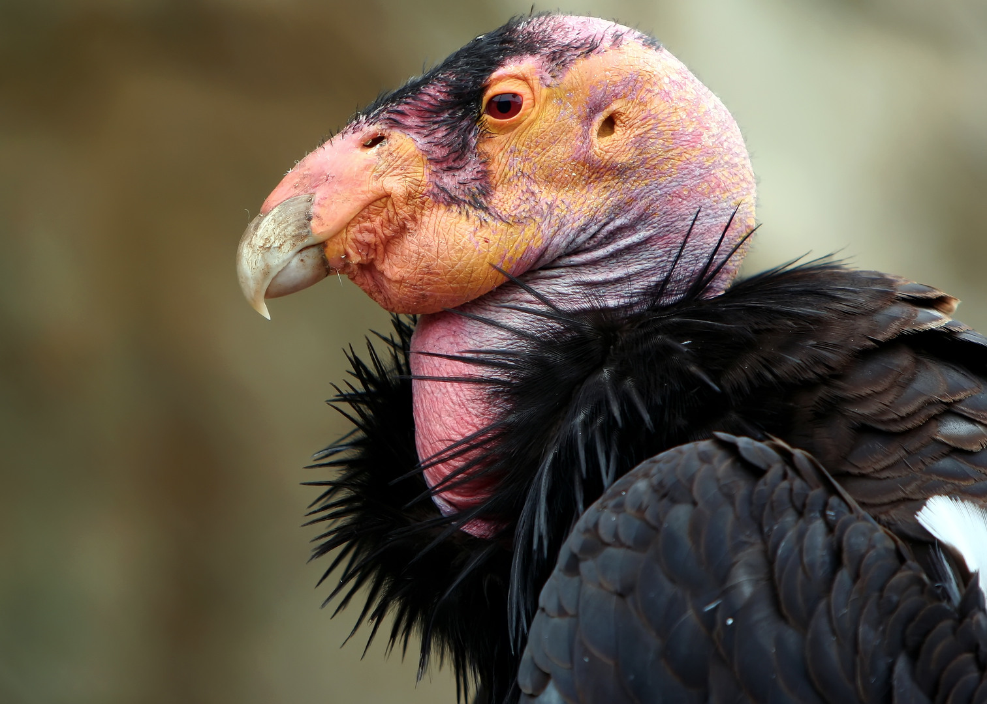

Vulture that became extinct in the wild in 1987, now there are experiments to reintroduce it to the wild (here in Utah!) but it’s already on the endangered list (less than 70 left)!

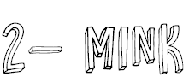

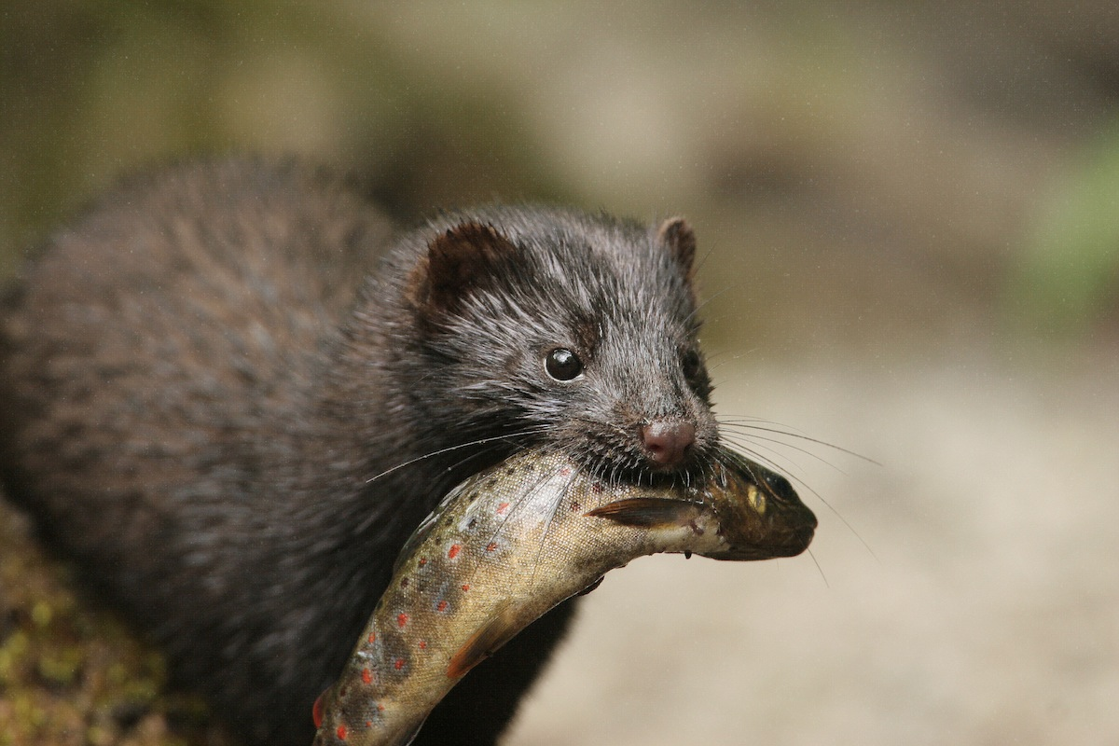

Mink are dark-colored, semiaquatic, carnivorous mammals. The American mink's fur has been highly prized for its use in clothing, with hunting giving way to commericial farming.

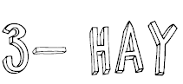

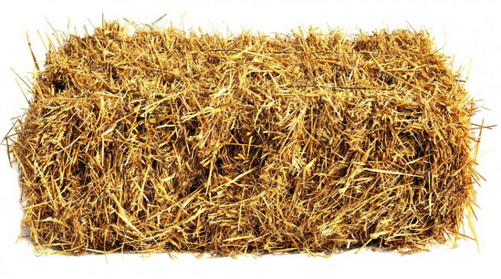

Plants that have been cut, dried, and stored
for use as animal fodder, particularly for
grazing animals such as cattle.

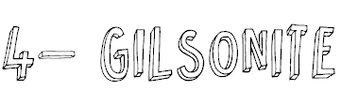

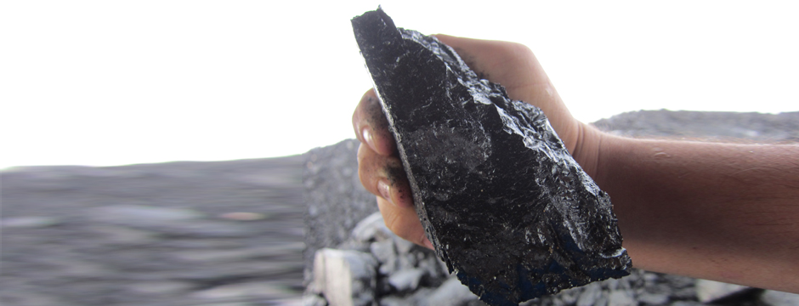

Gilsonite is mined in underground shafts and resembles shiny black obsidian. This unique mineral is used in more than 160 products, primarily in dark-colored printing inks and paints, oil well drilling muds and cements, asphalt modifiers, foundry sand additives, and a wide variety of chemical products.

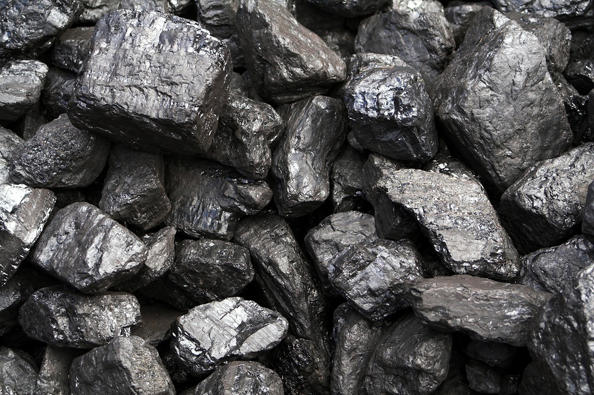

Coal (from the Old English term col, which has meant "mineral of fossilized carbon" since the 13th century) is a combustible black or brownish-black sedimentary rock usually occurring in rock strata in layers or veins called coal beds or coal seams.
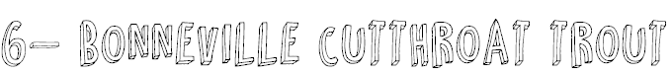

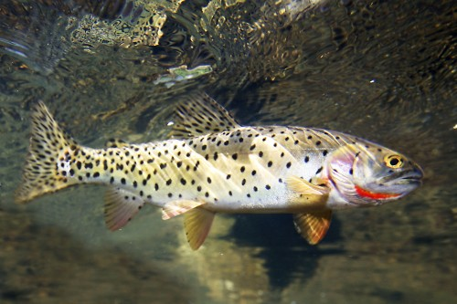

Utah’s State Fish! Bonneville Cutthroat is native to Utah and was important to the Indians and the Mormon pioneers as a source of food. There are some that speculate the pioneers were saved from starvation many times by catching and eating fish but claim it wasn't necessarily the trout that they ate but carp. Oh well!
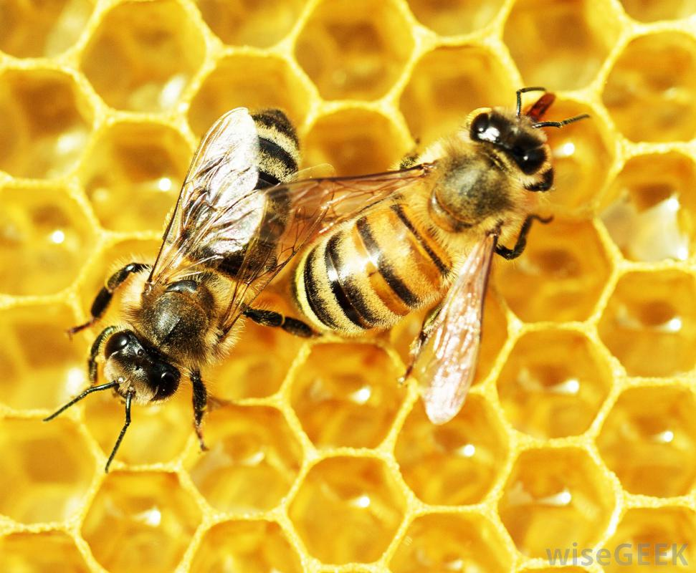

Honey Bees are Important Pollinators.
Pollination is the movement of male pollen to the female part of the flower (stigma), the first step in successful seed and fruit production by the plant. Self-pollination
is when pollen is transferred from the anther to
the stigma within a single plant.
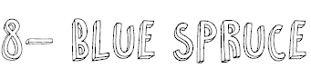
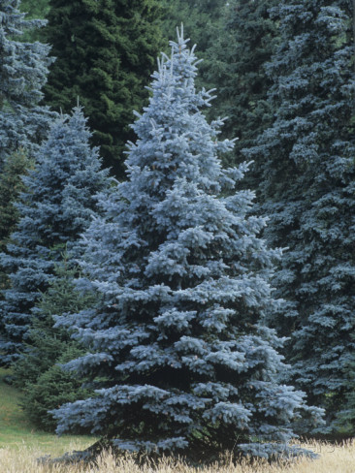
It is native to the Rocky Mountains of the United States. Its natural range extends from Colorado to Wyoming but it has been widely introduced elsewhere and is used as an ornamental tree in many places far beyond its native range.
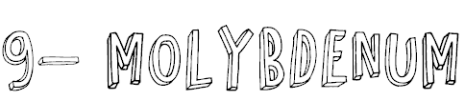
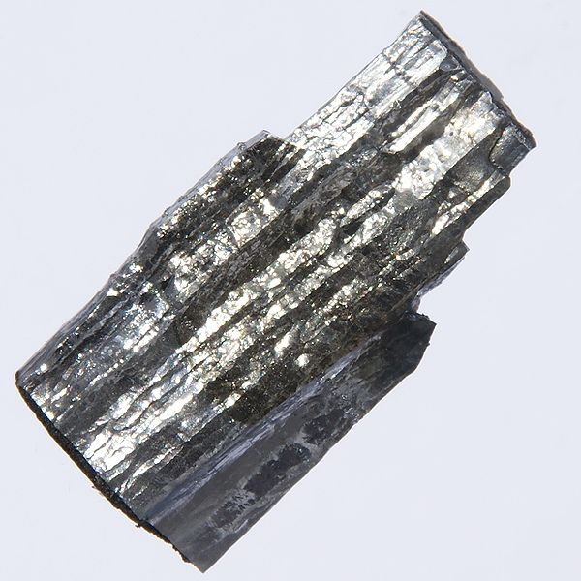

It readily forms hard, stable carbides in alloys, and for this reason most of world production of the element (about 80%) is in making many types of steel alloys, including high strength alloys and superalloys. It is also a trace mineral found in foods like milk, cheese, grains, legumes, nuts, organ meat, and leafy veggies.

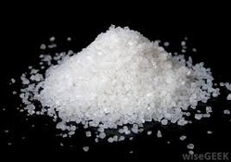

Potassium salt provides a "half-salt" substitute, which incorporates the flavoring benefits of sodium chloride salt with the health benefits of a serving of potassium.

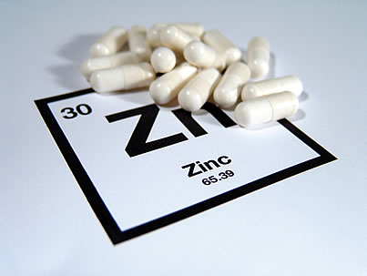

From a food standpoint, zinc may be a less familiar dietary mineral than iron or calcium or sodium, but it is no less important to our metabolism or our health.

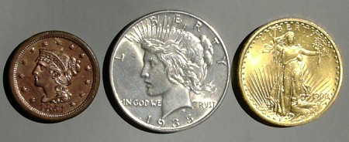

Copper, silver and gold are found in elemental or "native" form at the earth's surface. The best nuggets have been picked up already, since the land has been scoured for them wherever there are people who appreciate them. They are called the currency metals, since they have been used in coins since the beginning of money. The three are ductile, capable of being drawn into fine wires, and malleable, capable of being hammered into thin sheets. Gold, indeed, is outstandingly ductile and malleable, able to be drawn into wires thinner than a hair and beaten into sheets thin enough to transmit light. All three metals are important in technology, especially in electronics.

