John Deere was an Illinois blacksmith and manufacturer. Early in his career, Deere and an associate designed a series of farm plows. In 1837, on his own, John Deere designed the first cast steel plow that greatly assisted the Great Plains farmers. The large plows made for cutting the tough prairie ground were called "grasshopper plows." The plow was made of wrought iron and had a steel share that could cut through sticky soil without clogging. By 1855, John Deere's factory was selling over 10,000 steel plows a year.

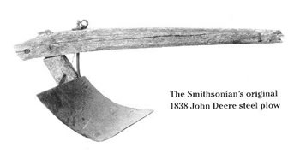

Not long after Eli Whitney invented the Cotton Gin, Cyrus McCormick invented another significant agricultural invention that revolutionized farming: the mechanical reaper. Prior to this invention, reaping was a painstaking process (done by hand with a scythe) that limited a farm's harvest.
The initial idea and design for the reaper actually came from Cyrus McCormick's father, Robert, who worked on the invention for 16 years. In 1831, twenty-two-year-old Cyrus took over his father's project and, within six weeks, he had built, field-tested, remodeled and successfully demonstrated the world's first mechanical reaper. McCormick's invention automatically cut, threshed and bundled grain while being pulled through a field by horses.
In 1834, inventor Cyrus McCormick took out a patent on his invention and, soon after, began manufacturing the reaper himself. Despite the amazing potential of the invention, most farmers remained uninterested.
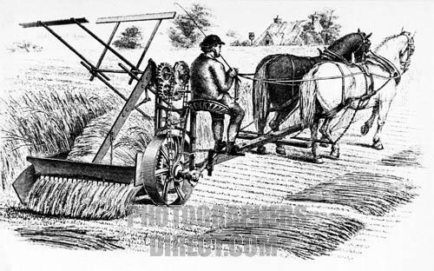
McCormick spent years making improvements to the mechanical reaper invention and coming up with business innovations to boost sales (including credit for purchases, performance guarantees, replacement parts and advertising). All his work eventually paid off – by 1851, Cyrus McCormick's reaper invention was an international sensation.

The thrashing machine, or, in modern spelling, threshing machine (or simply thresher), was first invented by Scottish mechanical engineer Andrew Meikle for use in agriculture. It was devised (c.1786) for the separation of grain from stalks and husks. For thousands of years, grain was separated by hand with flails, and was very laborious and time consuming, taking about one-quarter of agricultural labor by the 18th century. Mechanization of this process took much of the drudgery out of farm labour.

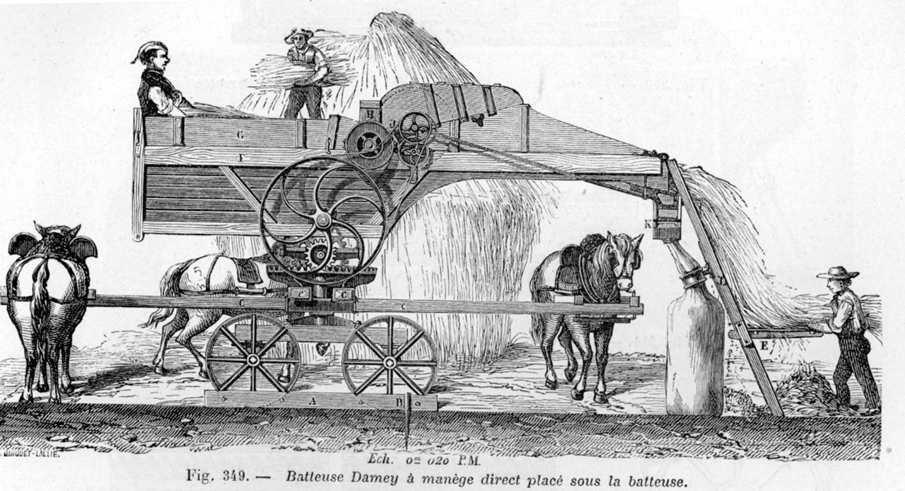

Developed in the 1830s and 1840s by Samuel Morse (1791-1872) and other inventors, the telegraph revolutionized long-distance communication. It worked by transmitting electrical signals over a wire laid between stations.
In 1844, Morse sent his first telegraph message, from Washington, D.C., to Baltimore, Maryland; by 1866, a telegraph line had been laid across the Atlantic Ocean from the U.S. to Europe. Although the telegraph had fallen out of widespread use by the start of the 21st century, replaced by the telephone, fax machine and Internet, it laid the groundwork for the communications revolution that led to those later innovations.

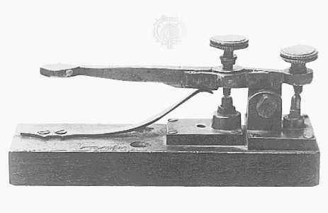

To transmit messages across telegraph wires, in the 1830s Morse and Vail created what came to be known as Morse code. The code assigned letters in the alphabet and numbers a set of dots (short marks) and dashes (long marks) based on the frequency of use; letters used often (such as “E”) got a simple code, while those used infrequently (such as “Q”) got a longer and more complex code. Initially, the code, when transmitted over the telegraph system, was rendered as marks on a piece of paper that the telegraph operator would then translate back into English. Rather quickly, however, it became apparent that the operators were able to hear and understand the code just by listening to the clicking of the receiver, so the paper was replaced by a receiver that created more pronounced beeping sounds.

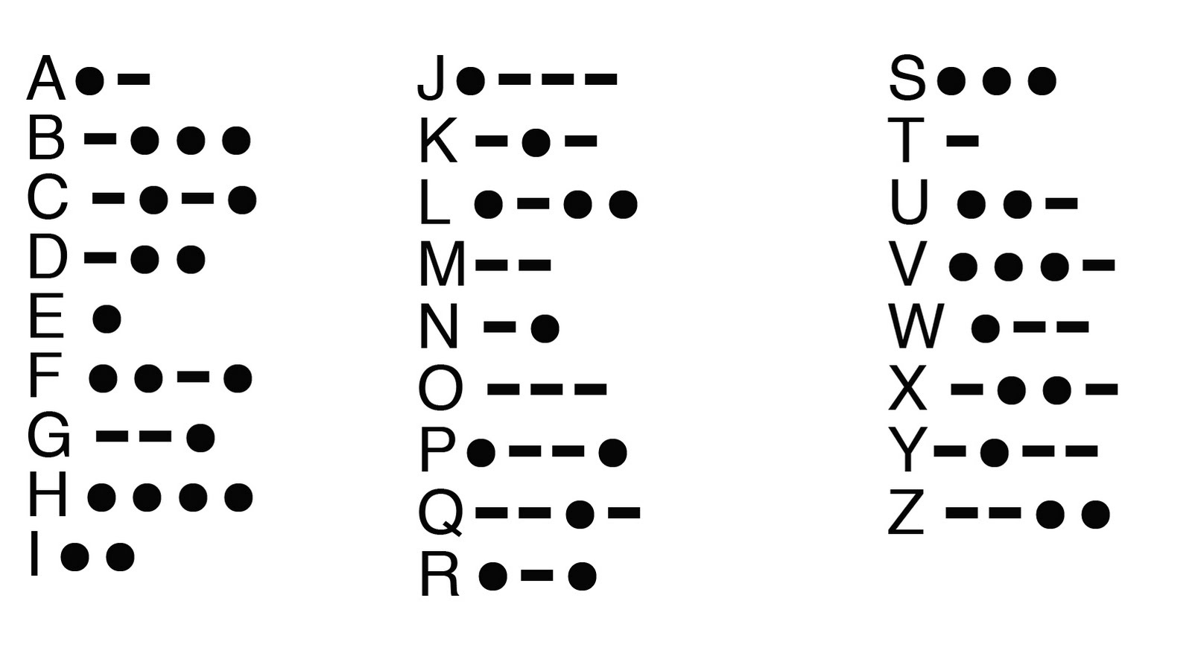

In 1769, the Scotsman James Watt patented an improved version of the steam engine that ushered in the Industrial Revolution. The idea of using steam power to propel boats occurred to inventors soon after the potential of Watt's new engine became known.

The era of the steamboat began in America in 1787 when John Fitch (1743-1798) made the first successful trial of a forty-five-foot steamboat on the Delaware River on August 22, 1787, in the presence of members of the Constitutional Convention. Fitch later built a larger vessel that carried passengers and freight between Philadelphia and Burlington, New Jersey.

Then came American inventor, Robert Fulton, who successfully built and operated a submarine (in France) in 1801, before turning his talents to the steamboat. Robert Fulton was accredited with turning the steamboat into a commercial success. On August 7, 1807, Robert Fulton's Clermont went from New York City to Albany making history with a 150-mile trip taking 32 hours at an average speed of about 5 miles-per-hour.
